LARGER NUMBER IN AN ARRAY

lxi h,2001

mov b,a

inx h

mov a,m

loop: inx h

cmp m

jnc lp

mov a,m

lp: dcr b

jnz loop

sta 2010

Hlt

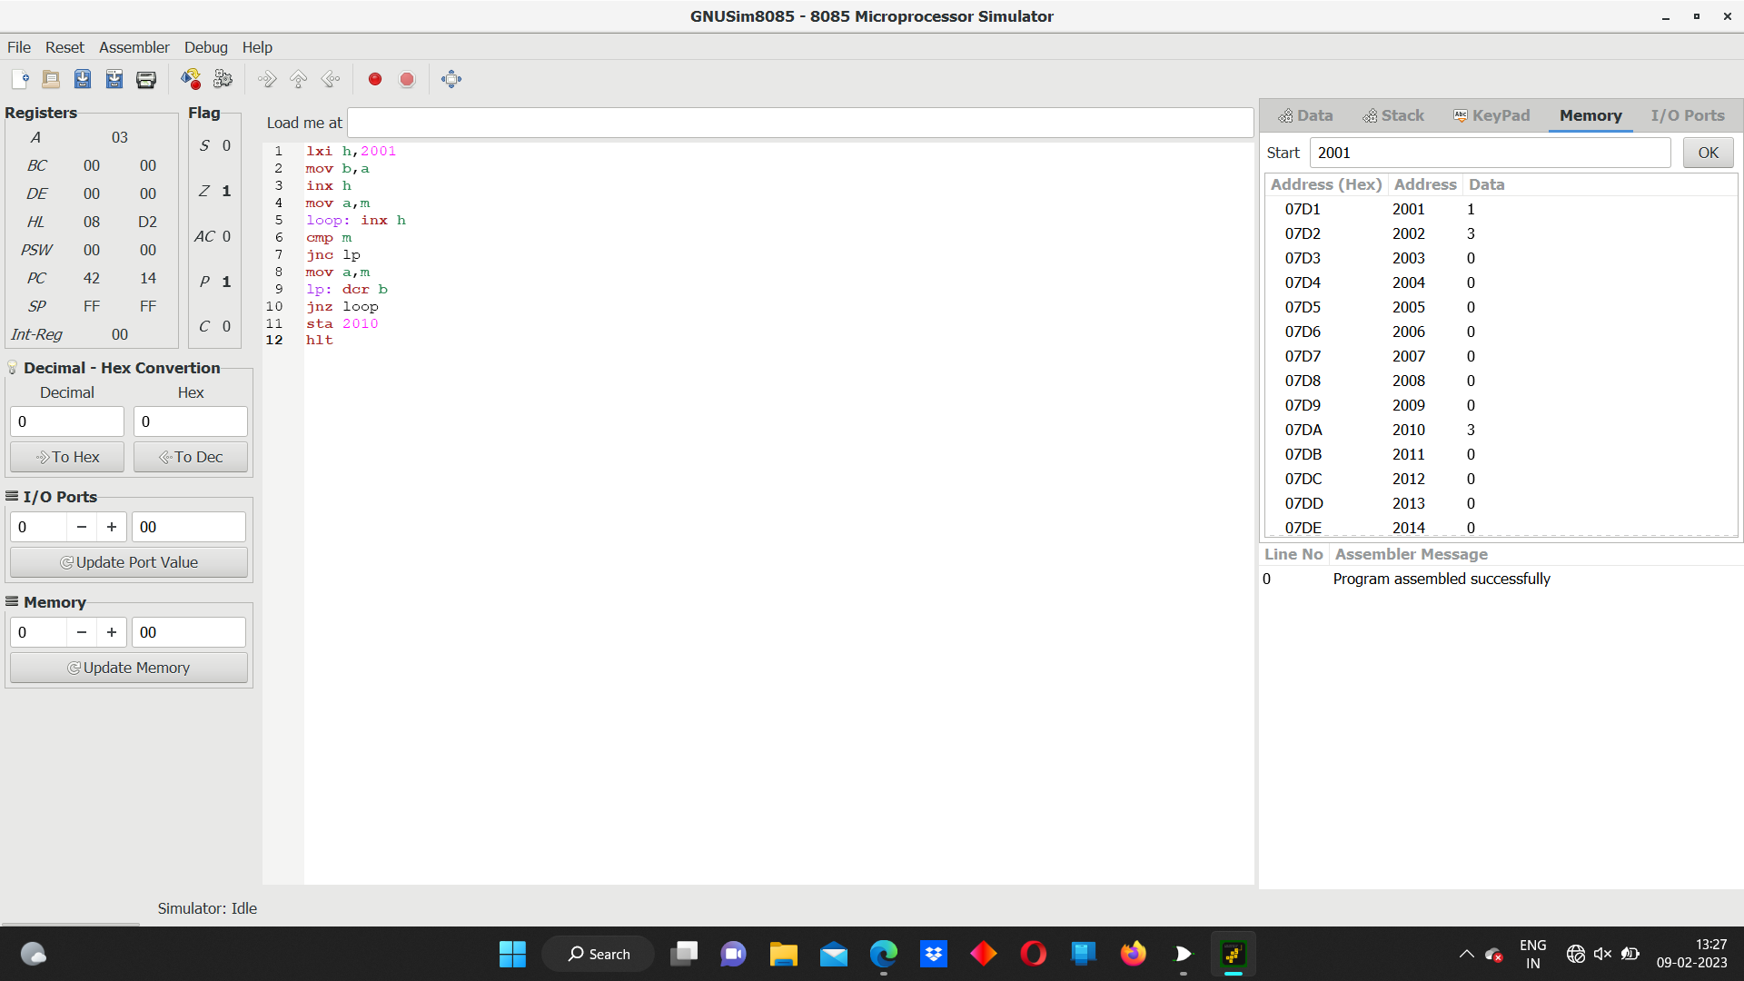s